# Attacks --

Udemy Course Url - <https://1drv.ms/o/c/6b364628c29feb52/EksLbbBuPIhDjFYNjtEw6kEB7wRxe5wd2oWXREL9gKphEg>

https://onedrive.live.com/:o:/g/personal/6B364628C29FEB52/EksLbbBuPIhDjFYNjtEw6kEB7wRxe5wd2oWXREL9gKphEg?resid=6B364628C29FEB52!sb06d0b4b3c6e43888c560d8ed130ea41&ithint=onenote&migratedtospo=true&redeem=aHR0cHM6Ly8xZHJ2Lm1zL28vYy82YjM2NDYyOGMyOWZlYjUyL0Vrc0xiYkJ1UEloRGpGWU5qdEV3NmtFQjd3UnhlNXdkMm9XWFJFTDlnS3BoRWc

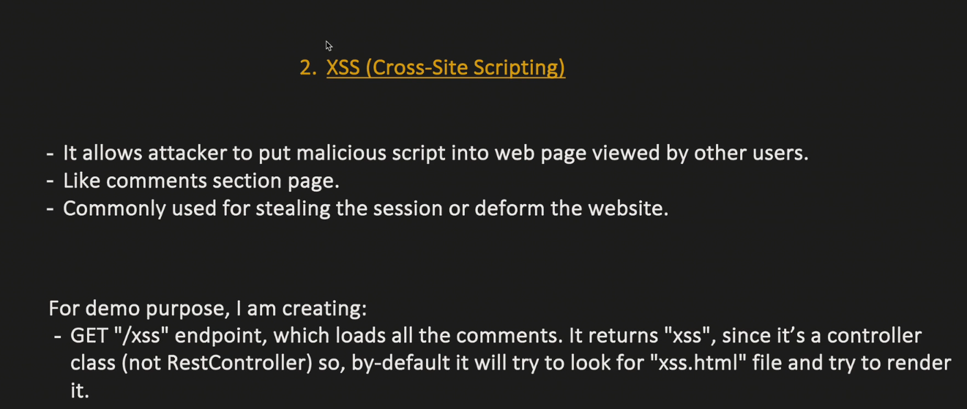

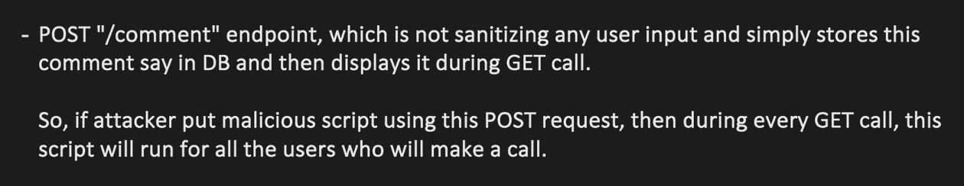

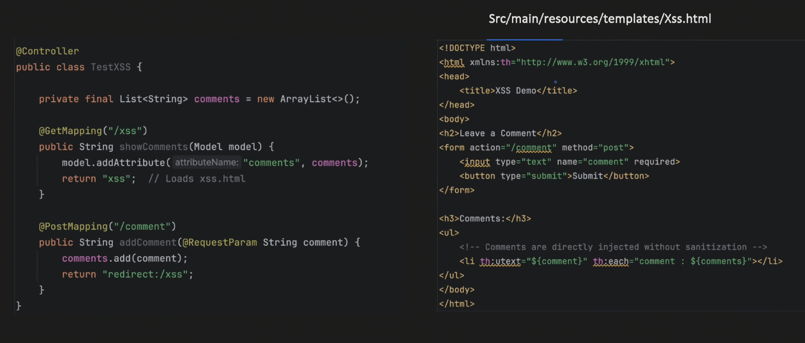

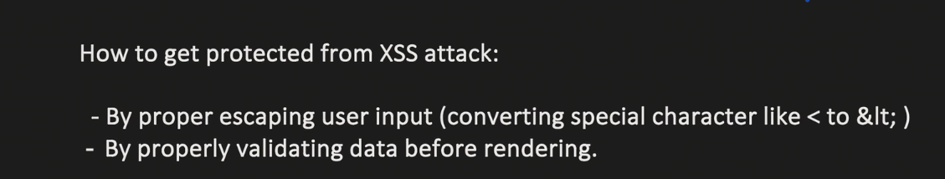

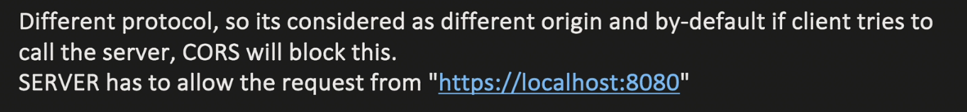

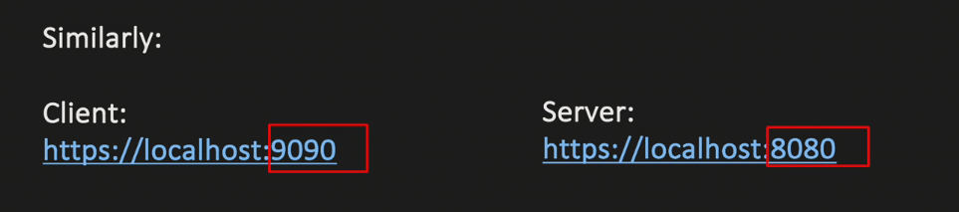

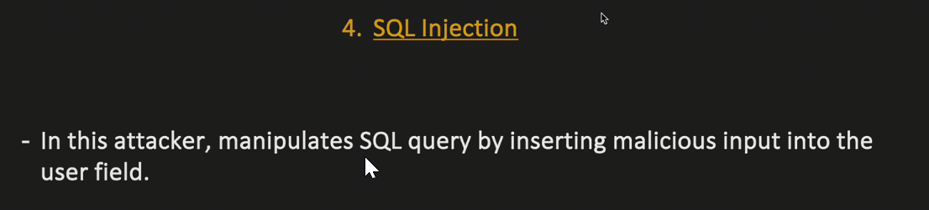

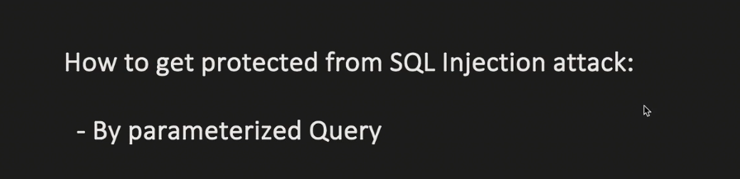

# Part 1 - Spring Security Architecture 🡪



